SportyHQ Instructions:
Adding your Team Order prior to each match
1. Go to the your SportyHQ team page. You should see a screen like this:
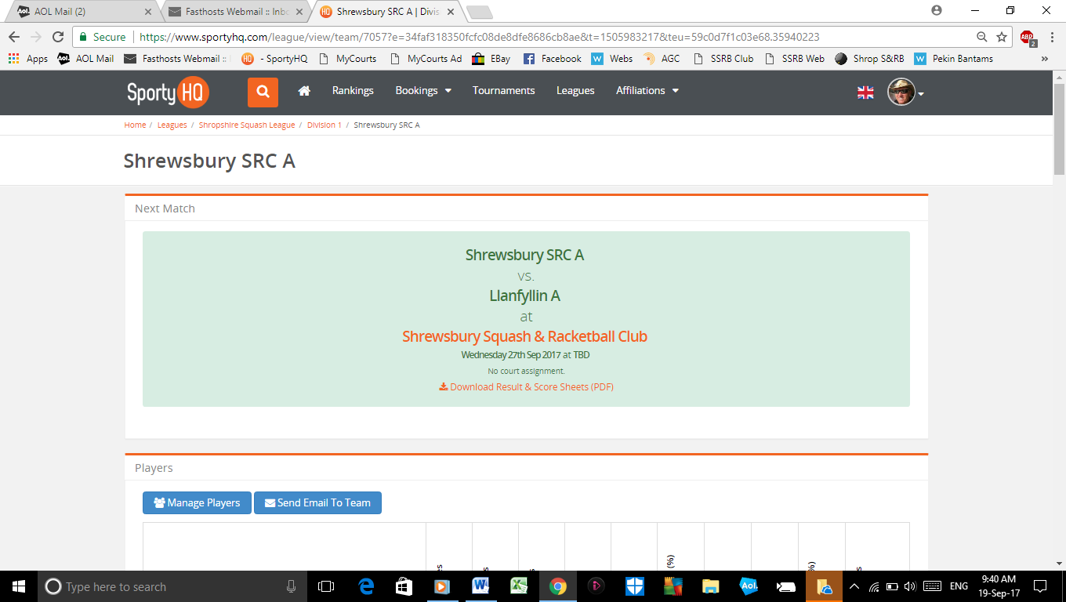
2. Scroll down the page until you get to the teams’ schedule. As below:
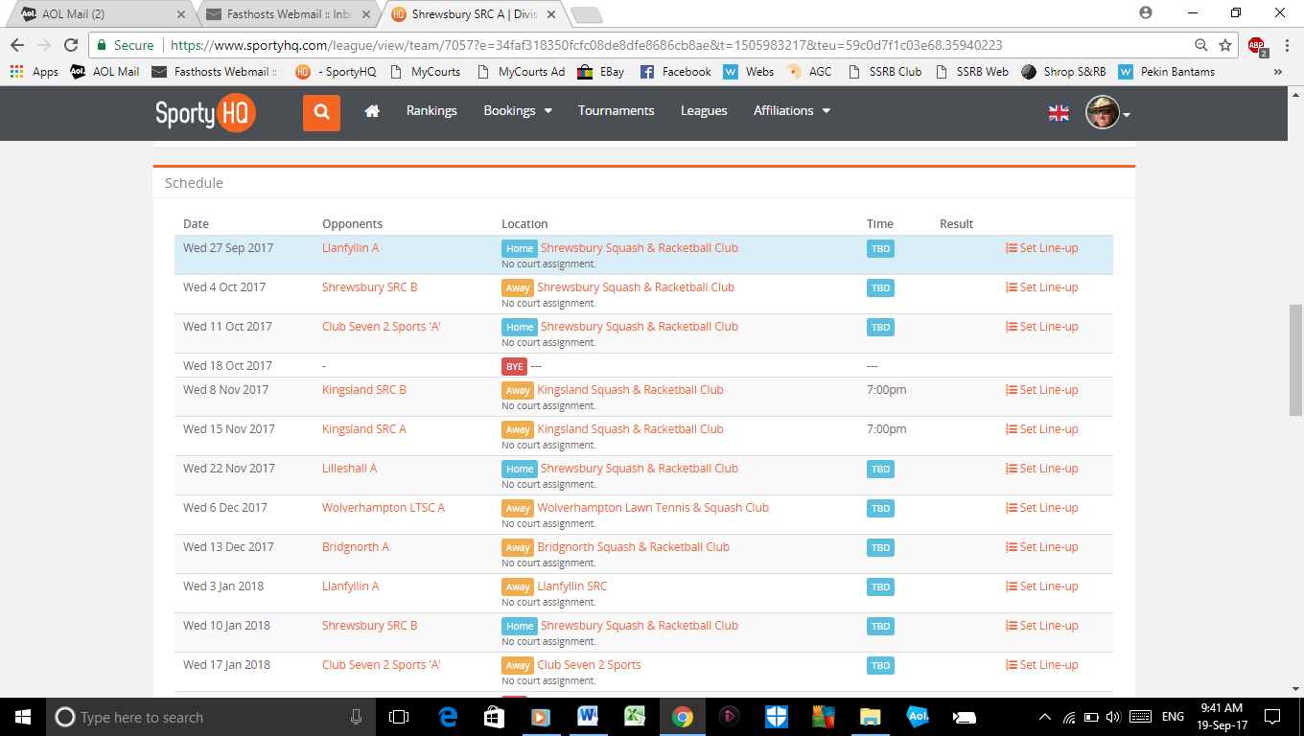
3. On the far right of that page you will see the column ‘Set Line-Up’. Click on this.
4. Your team will be on show with a column on the far left ‘Choose Line-Up’ – ‘Position’ . Pick the players you are playing and set their ‘Position’ 1 to 5.
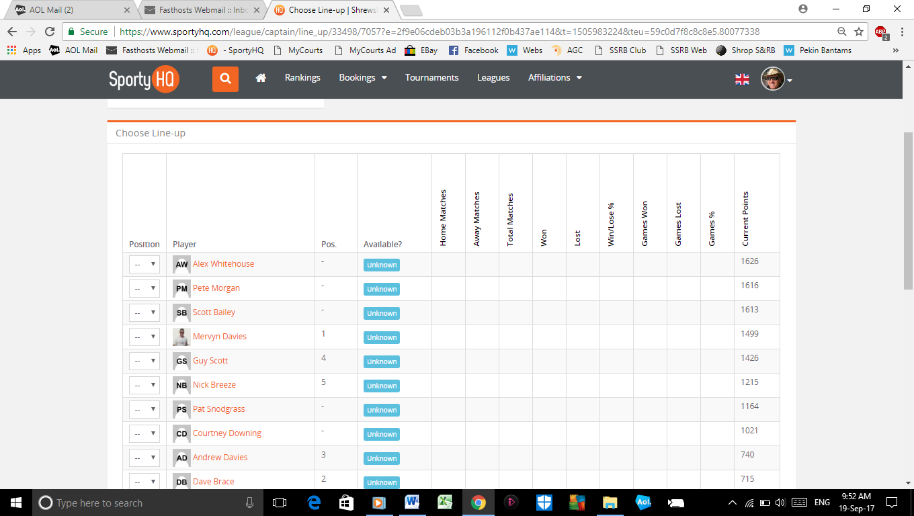
5. Scroll further down and you can send that team a message, if you wish, before clicking on the green button ‘save line-up’. This will send an email to your team as well as adding it to the top of your team page (as well as the top of the team page of your opponents for that week). (See the next Screen Shot)….
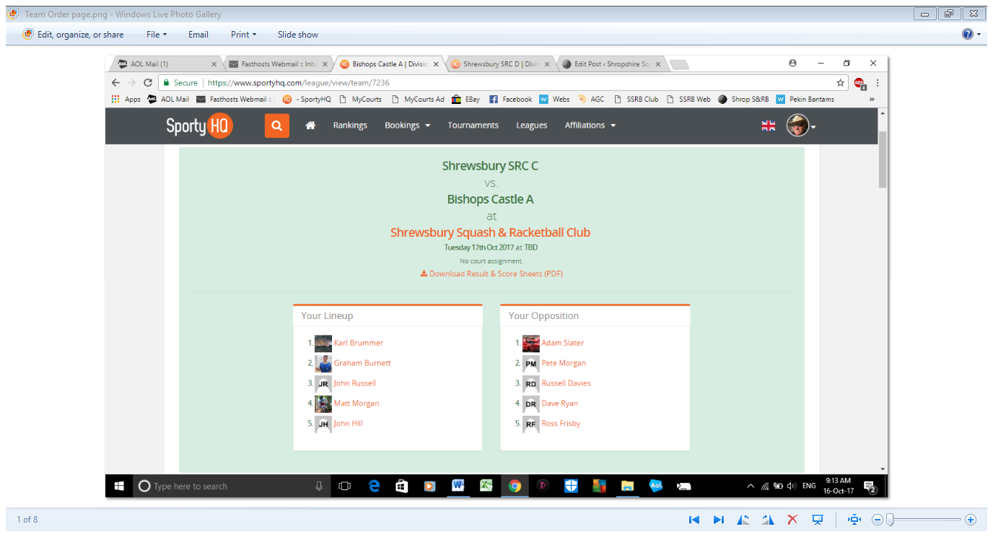
6. This should be done before each match to show your opponents your team.
7. If you see your Opponents team on top of your team page for that week, all you need to do is click on ‘Set Line-up’ and you will be able to do the same for your team.
8. In essence, this is your teams’ ‘Order of Merit’ for that week.
9. You will now, if you wish, be able to ‘download Result & Scoresheet’ which gives you a printed (if you print it) version of the team results sheet for that match, including both teams. This is really the only place where you will be able to see both teams’ order so that you know the players are playing in an appropriate order. (See next screen shot)…. You can also print off the individual score sheets for each game………it’s that easy. !!
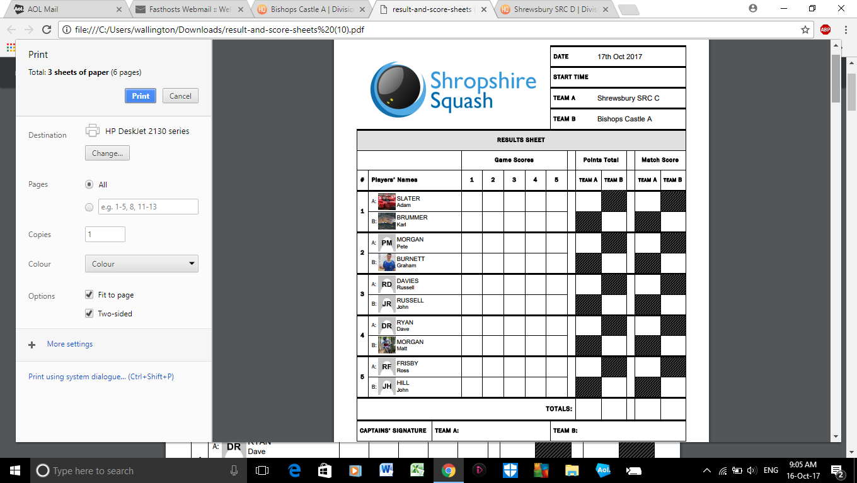
10. Any problems please contact the League Secretary at: don@shropshiresquash.org

