

**SportyHQ Instructions:**

**Entering Match results in the Shropshire Squash League or Cup**

1. Go to the SportyHQ schedule for your Division. You should see a screen like this:

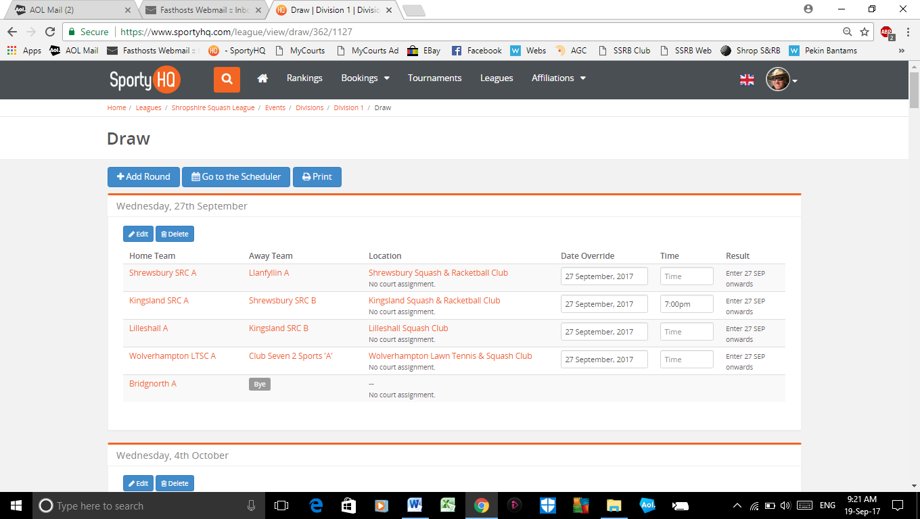

2. On the far right hand side you should see a column titled ‘Result’. Click on the ‘enter (date)’ for your teams’ match and you should see the fairly normal Squash results sheet. Fill the sheet in and ‘save’ (or ‘submit’) the results. You then get a confirmation box.

3. You can’t enter any results until on or after the date in the ‘enter (date)’ box.

4. Please enter the results within 24 hours of the date in the ‘enter – (date)’ box.

5. Any problems please contact the League Secretary at: don@shropshiresquash.org