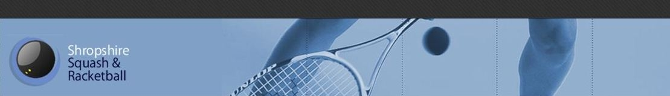
SportyHQ Instructions:
To check whether a player is eligible to play:
1. Either search for the player in question or go to the appropriate team page and select the players’ name.
2. The players’ page should look like:
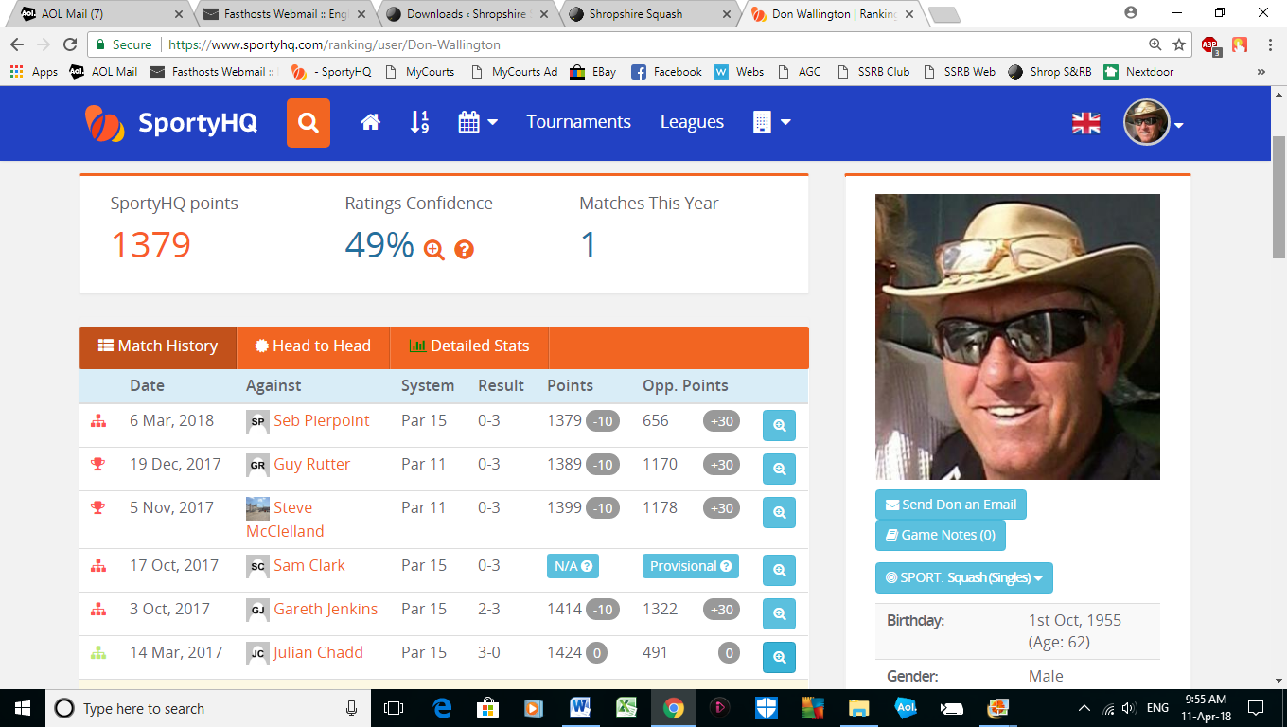

3. Select the magnifying glass icon on the right hand side of each line and you can see which division the match was played.
4. Rule 9.1 ANYONE playing more than four times for a team will be ineligible to play for a lower team during that season.
5. If you consider an opposing player is / was ineligible to play please contact the League Secretary at: don@shropshiresquash.org

