Adding your Team and Seeding the Players.
Get your team......
1. Go to the Shropshire Squash League Division and click on 'Your teams' name’.
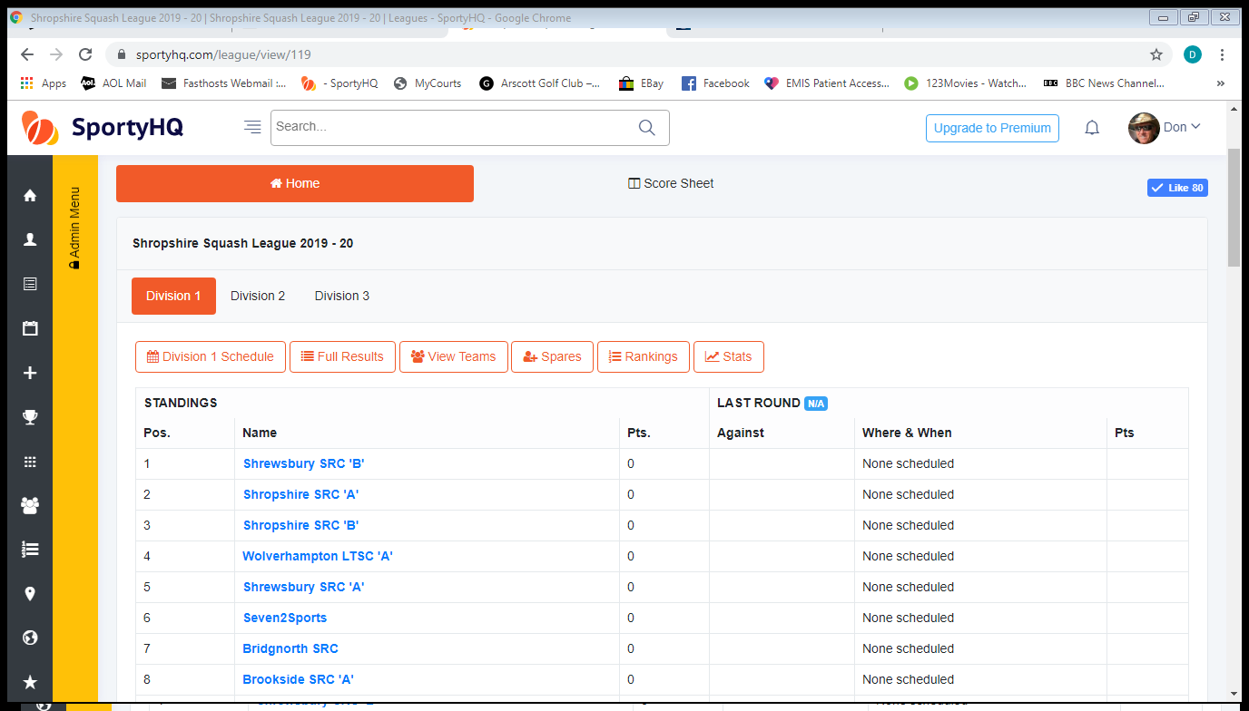
2. Once on your team page go down the page until you see the red block 'manage players'.
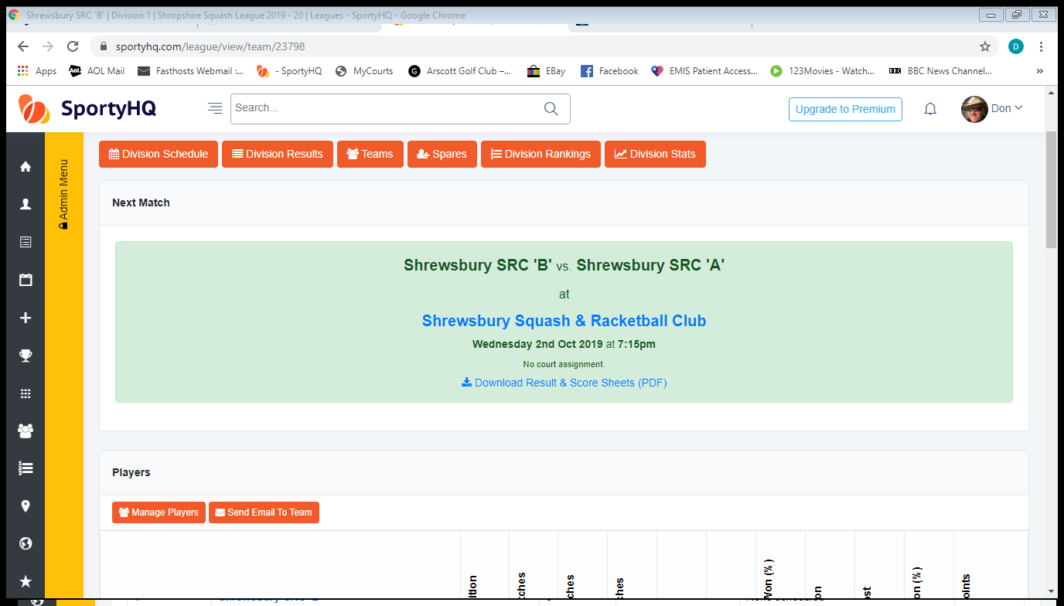
3. Once on the 'manage players' page, click in the box 'add a new team member'.
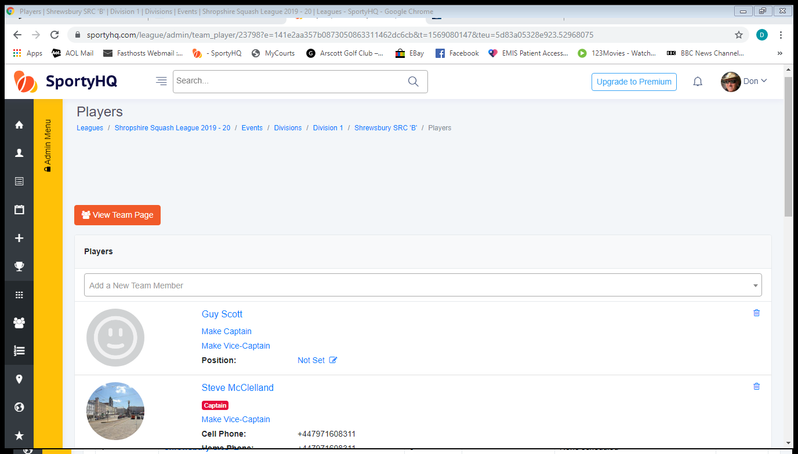
4. When you've typed in the player’s name just click on the appropriate player and that player will be added to your team. Repeat until you've got all your players in your team.
Now seed the players .......
1. Go to the first entry and look for where it says 'Position' (it will probably also say 'spare' or 'not set' as a blue word)
2. Click on the 'spare' or 'not set' blue word (opposite the word 'Position') and a box will appear. It will say ‘(name of player)’ usually plays at .....' click on the list button and the position 1 - 5 will appear as well as the word 'spare'.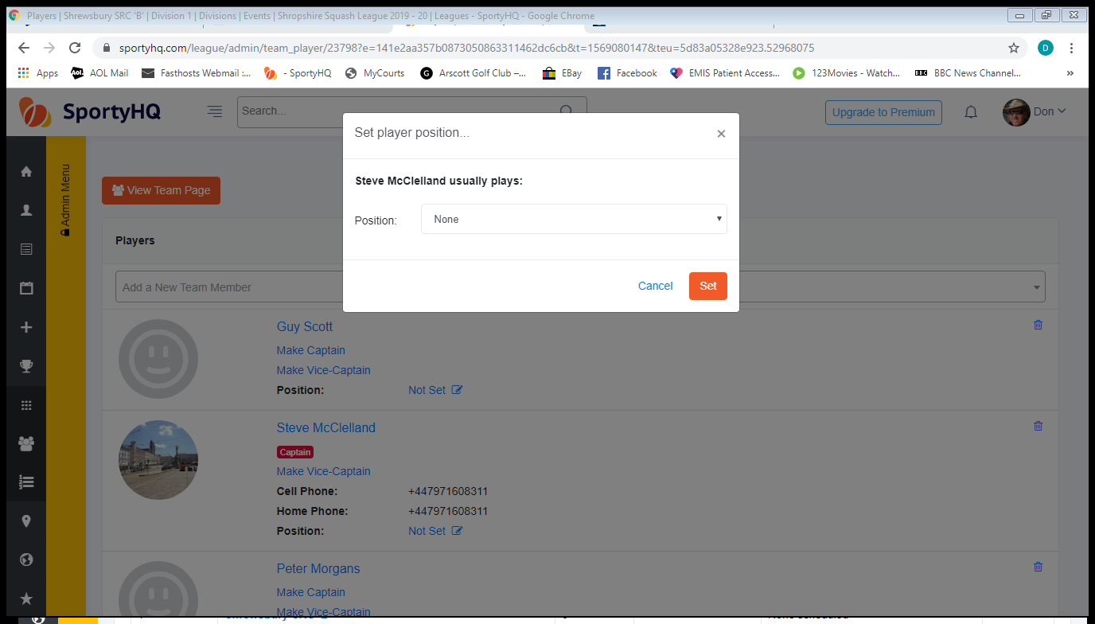
3. Add the appropriate number to the player (1 – 5 for Squash & 1 – 4 for Racketball) and click the red 'set' button. That player will now be seeded as the number you selected.
4. Add a seeding number to every player. Your team can have numerous number 1's, 2's, 3's, 4's and 5's.

